ZHARKENT COLLEGE OF HUMANITIES AND TECHNOLOGY
The subject: | Foreign language
The theme of the lesson: | Education in Australia. Famous people of Australia and their achievements
Date: 04.11.2018. | The teacher’s initials: | Rozakhunova G.S.
Group: 204 | Participating students: | Absent students:
The objectives of the lesson: | - Introducing and practicing with new material, speech activities on the theme “Education in Australia. Famous people of Australia and their achievements”. To bring up students’ interest in English speaking countries.
Expected result: | All learners will be able to read and translate the text.  Most learners will be able to answer the questions.  Some learners will be able to retell the text.
Resources | Interactive board, the map, text, exercises, posters, markers, video material, cards.
Previous materials | The famous sightseeing in Australia.
Plan

Stages | Planned activity of the lesson |  | Used methods
The start of the lesson  Division into groups | Greeting  Warm up:  The teacher: All of you come here and form a circle. Look at each other smile, and say “Hello”! I want you say that you are the best students. I want wish you all the best wishes in the world. I give you a chance to say the best wishes and complements to each other! Let’s begin!  I have a box. There are cards for you in the box. Choose it!  In your cards you can see the picture of kangaroo, koala bear, and emu. Let’s divide into three group.  The 1 group “Kangaroo”  The 2 group “Koala bear”  The 3 group “Emu” Take your sits!  And what can you say about these animals and bird?  Yes, you are right!  Let’s watch the video and remember our previous materials!  Task 1: “Find the cards”  The tasks are in our classroom and they stick on. Please find them.  1.Geographical position of Australia – work with the map |  | T-Cl  Listening  Group work  Speaking  The map
The middle of the lesson  The end of the lesson. | 2. Political system of Australia – make the poster  3. Sightseeing of Australia - make the presentation  It was your home task. Good work. Thank you very much.  Today we continue to speak about Australia. The theme of our lesson is  “Education in Australia. Famous people of Australia and their achievements”.  Vocabulary:  Compulsory [kәm ‘pʌlsәri] – обязательный  State school [steit sku:l] – государственная школа  Private school [ptaivit sku:l] – частная школа  Tuition [tju: ‘iʃ(ә)n] – обучение  Primary school [praimәri] – начальная школа  Secondary school [‘sekәndәri] – средняя школа  Schools of the Air [sku:ls ov Ϡe eә(r)] – воздушные школы  To assign [ә ‘sain] - определять  1-slide  Education in Australia  Compulsory  for all children from  6 to 15 years  Private schools  20%  Private schools charge is rather high fees  State schools  80%  Tuition is state schools is free of charge  2 slide  Most children begin primary school at the age of about 5. Primary schools include from 1 to 6 or 7 grades. After the primary school children pass to the secondary school without examination. Junior high school comprise 4 or 3 – years courses. After these courses students complete two-year senior high school. After senior classes of secondary school’s students may enter any higher educational institution in the country.  3 slide  Schools of the Air  Students living far from the city attend “Schools of the Air”. They listen to the teacher on the radio each day when it’s time for school. Students have their own books. They answer the questions over the microphone. The teacher assigns home-work to do. The completed home work is mailed to the teacher. It is discussed over the microphone corrected and mailed back.  Task 2: Match the two parts of the sentences. Write them down.  Example: In state schools of Australia education is free.  a) In Australia education is compulsory...  b) In state schools of Australia education is...  c) There are some Australians who live...  d) Schools of the Air are usually situated...  e) Two-way radio and television help to learn...  f) Schools through the mailbox are for students who live...  ...the world around them.  ...in remote inland towns.  ...at age 6-15.  ...far away from the big cities.  ...free.  ...far from any school in the area.  Task 3: Read the text.  Famous people in Australia and their achievements  A number of Australian actors have found international success, including the Academy-winning Geoffrey Rush, star of Shine and The King's Speech. Russell Crowe, Nicole Kidman and Cate Blanchett have also claimed the Best Actor honour. Action hero Hugh Jackman is also a Tony Award-winning singer and dancer.  Nicole Kidman’s career includes:  • an Oscar (2002) for her portrayal of Virginia Wolf in "The Hours",  • 3 Golden Globe awards: in 1995 for her role in "To Die For", in 2001 for "Moulin Rouge", in 2002 for "The Hours"; several nominations for the Golden Globe and Oscar.  With such a career it is not a wonder that in 2006 she topped the list of the highest-paid actresses.  In 2008 she starred next to one of the other great Australian actors, Hugh Jackman in the epic movie "Australia", directed by Baz Luhrmann.  Cate Blanchett began her career in theatre in 1992. Two years later she played Ophelia in the "Hamlet" production of the "Company B" theatre in Sydney.  "Paradise Road", directed by another famous Australian, Bruce Beresford, marked her international debut in a movie in 1997.  In 1998 her astonishing portrayal of Queen Elizabeth I won her a Golden Globe, a BAFTA award and an Oscar nomination.  Playing strong and influential characters proved a successful strategy for Cate Blanchett:  In 2005 she won an Oscar for starring as Katherine Hepburn in "The Aviator" by Martin Scorsese.  She received three Oscar nominations: for best supporting actress in "Notes on a Scandal", (2006), for the best actress in "Elizabeth the Golden Age", the sequel to her first movie "Elizabeth"(2007),for best supporting actress in "I'm Not There", where she played one of the six Bob Dylan characters in the picture, (2007).  Hugh Jackman is a versatile actor, singer and dancer and, to top it all, he is a producer too.  He graced the stage of the 2009 Oscars by hosting the event and presenting the awards.  Hugh Jackman's international career started with theatre in London. His performance in the musical "Oklahoma" won him an Olivier award nomination in 1998.  Two years later he took on the Wolverine role in "X-Men" and rose to celebrity status. He continued with this role in several sequels in 2003, 2006 and 2009.  In 2001 Hugh Jackman received a Golden Globe nomination for best actor in the movie "Kate and Leopold".  His love for music and the stage won him a Tony Award for his performance in the "Boy from Oz" on Broadway in 2004.  Famous Australians scientists  Pharmacologist and pathologist Howard Florey shared a Nobel Prize in 1945 for his work extracting penicillin. Other Australian scientists have also made significant contributions in their various fields.  Famous Australian inventors and famous Australian inventions  Australia's Aboriginal people invented the aerodynamic boomerang. Professor Ian Frazer 2006, Australian of the Year, invented a vaccine to prevent cervical cancer. Other famous Australian inventions include aspirin (1915), penicillin (1940), plastic disposable syringe (1949), and long-wearing contact lenses (1999). Australia's famous people include cardiac surgeon Victor Chang, who pioneered an artificial heart valve.  Famous Australian explorers  Following Captain Cook's 1770 landing, and the arrival of the First Fleet in 1788 a number of early explorers set out to discover Australia. Other famous people of Australia  Task 4: True or False.  Correct the false sentences.  1. Cate Blanchett starred next to one of the other great Australian actors, Hugh Jackman in the epic movie "Australia".  2. Cate Blanchett received an Oscar nomination for the best actress in "Elizabeth the Golden Age".  3. Hugh Jackman took on the Wolverine role in "X-Men" and rose to celebrity status.  4. In 2001 Hugh Jackman received a Tony Award for best actor in the movie "Kate and Leopold".  5. Professor Ian Frazer 2006, Australian of the Year, invented an artificial heart valve.  6. Cardiac surgeon Victor Chang pioneered a vaccine to prevent cervical cancer. |  | Poster, markers.  presentation  T-Cl  Writing  Group work  Reading
Reflection | I’ll give you reflection cards. Please complete the cards!  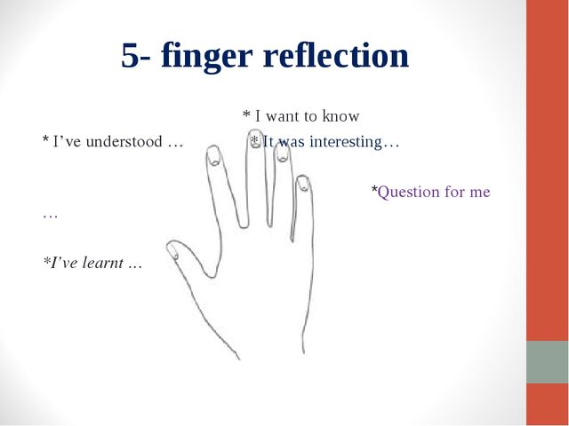
Assessment and home task: | Let’s evaluate the groups! I’ll give you smiley faces! The 1st group evaluate the 2nd group, the 2nd group evaluate the 3rd group and the 3rd group evaluate the 1st group showing the smiley faces!  Excellent! Good! Satisfactory!  Some of you did very interesting reports. Of course, they have excellent marks. The special thank is for our chiefs. Also excellent marks. I see, you know a lot about Australia and its people.  Thank you very much for your work.  Now a few words about your homework. Work with vocabulary. Retelling the text: “Education in Australia”  Комплексная релаксация Т. (включают тихую музыку)  I think you are tired a little. Let’s relax. Please shut your eyes. Imaging you are at the Black Sea now. It is summer. The weather is wonderful. The sky is blue. The sun is shining. A light wind is blowing from the sea. The water in the sea is warm and pleasant. You are lying on the beach and enjoying all these wonderful things. You are quiet. You have no problems. Your family, your friends, your college, your teachers love you. You are happy. You have a good spirit. Please, breathe in. Breathe out\four times\ open your eyes now. How are you?  So, students, the lesson is over! Good bye!
Summary evolution
What two things went really well? (consider both teaching and learning)
1.
2.
What two things could improve the lesson? (consider both teaching and learning)
1.
2.
What I have learned from this lesson about the class or individuals that will inform my next lesson
1.
2.

The teacher: ________________
Checked up: ________________

